**EXPERIMENT NO. 6**

**TO IMPLEMENT AND COMPARE PERFORMANCE OF FILTERS FOR REMOVING SALT AND PEPPER NOISE AND GAUSSIAN NOISE**

**EXPERIMENT NO. 6**

**AIM:** To implement median filter for removal of salt and pepper noise and arithmetic mean filter for removal of Gaussian noise and compare their performances for different noise intensity and with different filter sizes.

**OBJECTIVES:**

1. To understand concept of impulse noise, gaussian noise
2. To understand process of restoration.
3. To compare the results of restoration by geometric mean and median filter for Gaussian and salt and pepper noise

**EQUIPMENTS/SOFTWARE:** SCILAB or Matlab 7.0

**THEORY:** Digital images are frequently affected by impulse noise during their acquisition or transmission in a noisy environment. Therefore, to efficiently remove noise from an image while preserving its features is a fundamental problem of image processing. The impulse noise can be classified either as salt-and-pepper with noisy pixels taking either maximum or minimum value, or as random valued impulse noise. The removal of fixed-valued impulse noise has been widely studied and a large number of algorithms have been proposed. The median filter is the most popular choice for removing the impulse noise from images because of its effectiveness and high computational efficiency.

The median filter is normally used to http://homepages.inf.ed.ac.uk/rbf/HIPR2/mote.gifreduce noise in an image, somewhat like the [mean filter](http://homepages.inf.ed.ac.uk/rbf/HIPR2/mean.htm). However, it often does a better job than the mean filter of preserving useful detail in the image.

Like the [mean filter](http://homepages.inf.ed.ac.uk/rbf/HIPR2/mean.htm), the median filter considers each pixel in the image in turn and looks at its nearby neighbors to decide whether or not it is representative of its surroundings. Instead of simply replacing the pixel value with the mean of neighboring pixel values, it replaces it with the median of those values. The median is calculated by first sorting all the pixel values from the surrounding neighborhood into numerical order and then replacing the pixel being considered with the middle pixel value. (If the neighborhood under consideration contains an even number of pixels, the average of the two middle pixel values is used.)

Figure 1 illustrates an example calculation.

As can be seen, the central pixel value of 150 is rather unrepresentative of the surrounding pixels and is replaced with the median value: 124. A 3×3 square neighborhood is used here --- larger neighborhoods will produce more severe smoothing.

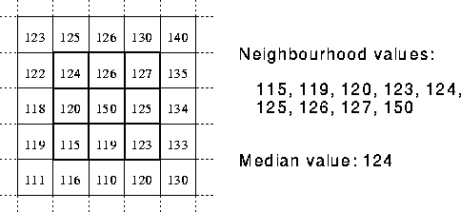

**Gaussian noise** represents [statistical noise](http://en.wikipedia.org/wiki/Statistical_noise) having [probability density function](http://en.wikipedia.org/wiki/Probability_density_function) (PDF) equal to that of the [normal distribution](http://en.wikipedia.org/wiki/Normal_distribution), which is also known as the [Gaussian distribution](http://en.wikipedia.org/wiki/Gaussian_distribution). In other words, the values that the noise can take on are Gaussian-distributed.

The probability density function pof a Gaussian random variable zis given by:

p_G(z) = \frac{1}{\sigma\sqrt{2\pi}} e^{ -\frac{(z-\mu)^2}{2\sigma^2} }

where z represents the grey level, \muthe [mean](http://en.wikipedia.org/wiki/Mean) value and \sigmathe [standard deviation](http://en.wikipedia.org/wiki/Standard_deviation).

Principal sources of [Gaussian noise](http://en.wikipedia.org/wiki/Gaussian_noise) in [digital images](http://en.wikipedia.org/wiki/Digital_image) arise during acquisition eg. [sensor noise](http://en.wikipedia.org/wiki/Sensor_noise) caused by poor illumination and/or high temperature, and/or transmission eg. [electronic circuit noise](http://en.wikipedia.org/wiki/Circuit_noise_level).

**Arithmetic mean filter:-**

In this filter centre pixel of g(x,y) is replaced

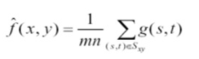

x,y belong to subimage.

**ALGORITHM:**

1. Read the image.
2. Add impulse noise to the image
3. Add Gaussian noise to the image.
4. Perform arithmetic mean and median filter on both the noisy images.
5. Compare the results of both the filtering

**FUNCTIONS USED (MATLAB / SCILAB):**

1. imread
2. imnoise
3. sort(MATLAB)/gsort(SCILAB)
4. imshow

**OUTPUT:**

**Original Image:**

**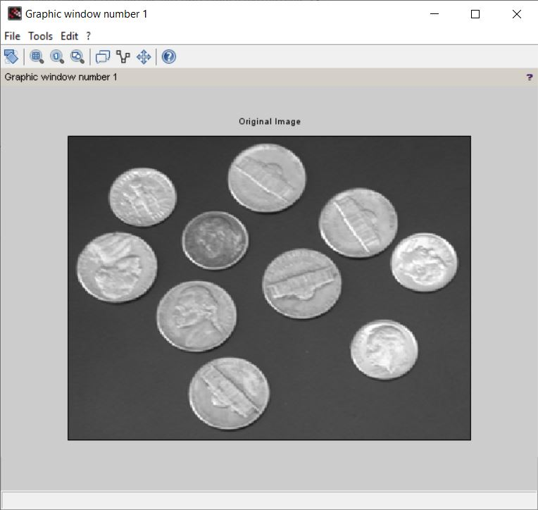**

**Noisy Image:**

**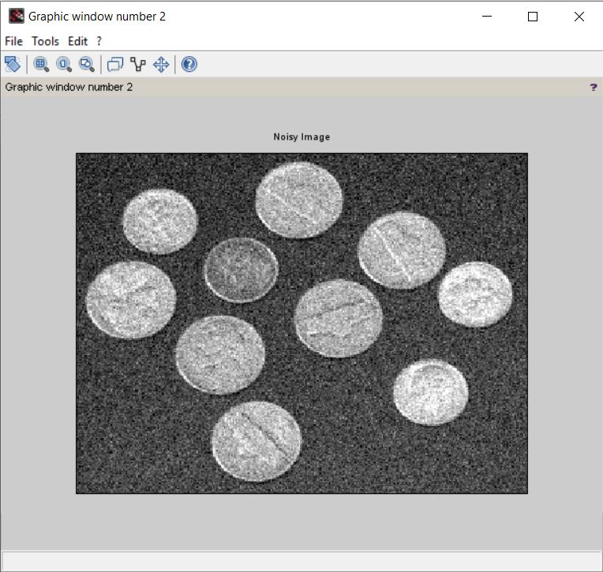**

**Output Image:**

**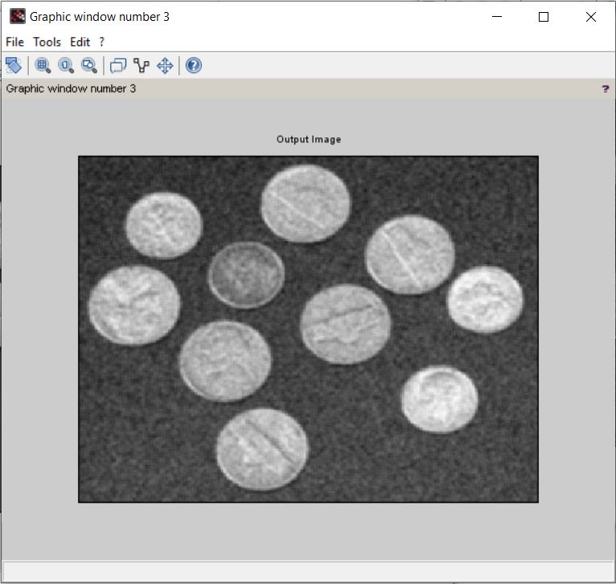**

**CONCLUSION:**

We studied and observed that:  
1) The median filter is normally used to http://homepages.inf.ed.ac.uk/rbf/HIPR2/mote.gifreduce noise in an image, somewhat like the [mean filter](http://homepages.inf.ed.ac.uk/rbf/HIPR2/mean.htm).

2) The median filter considers each pixel in the image in turn and looks at its nearby neighbors to decide whether or not it is representative of its surroundings.